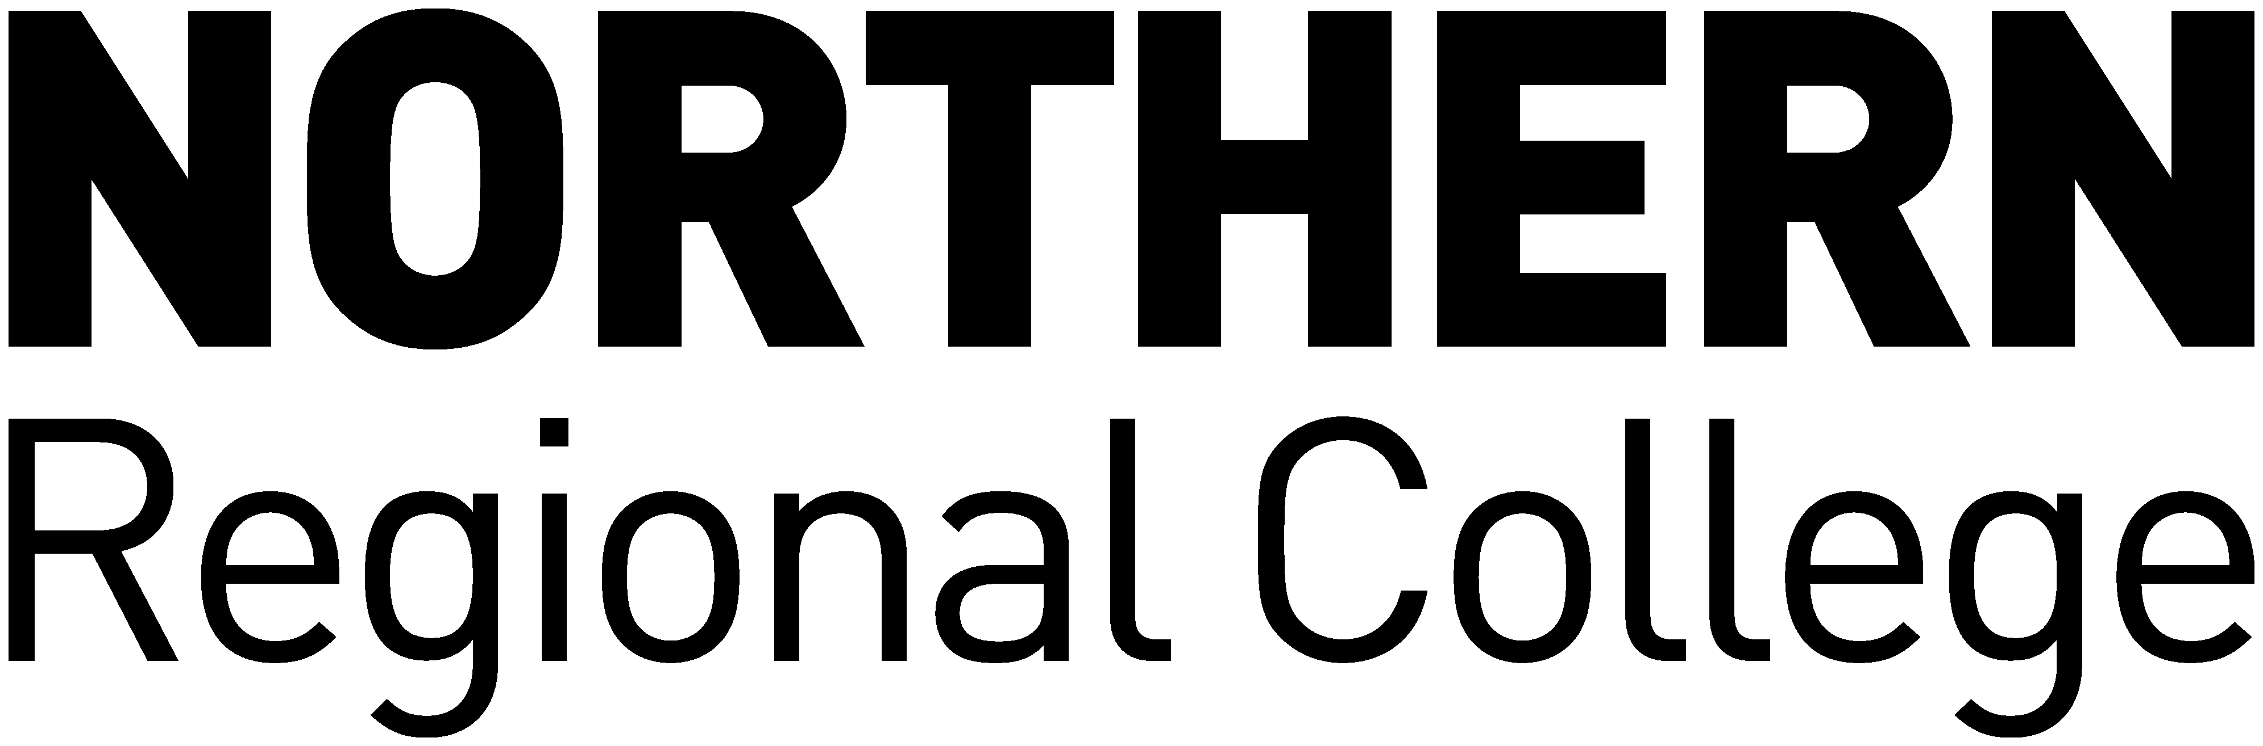

NORTHERN REGIONAL COLLEGE

Acceptance of Liability to Pay Fees
Students in Receipt of Funding

I, _____________________________________ (name of student in block capitals)
Of _____________________________________ (student’s home address)
_____________________________________
_____________________________________
_____________________________________

Hereby accept liability for payment of tuition fees in full due to Northern Regional College for
2024 – 2025 in the event that I am unsuccessful in my application for funding.

I understand that tuition fees must be paid in full regardless of period of attendance.

FOR OFFICE USE
Students Signature: Student Reg No:
Date: Receipt Number:

