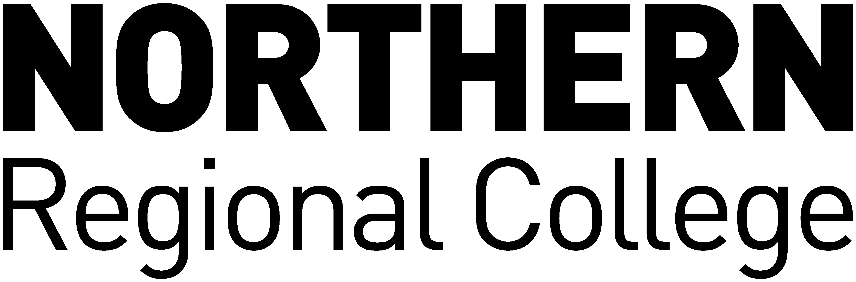

NORTHERN REGIONAL COLLEGE

Acceptance of Liability to Pay Fees
Academic Year 2024/25

I, _____________________________________ (name of student in block capitals)
Of _____________________________________ (student’s home address)
_____________________________________
_____________________________________
_____________________________________

Hereby accept liability for payment of tuition fees in full due to Northern Regional College for
2024 – 2025, in accordance with the College’s Policy on payment of fees by instalments. I have provided evidence of my funding application.

I understand that if I withdraw from the course I am still liable for payment of my fees in full.

FOR OFFICE USE
Students Signature: Student Reg No:
Date: Receipt Number:

